**Q1)**

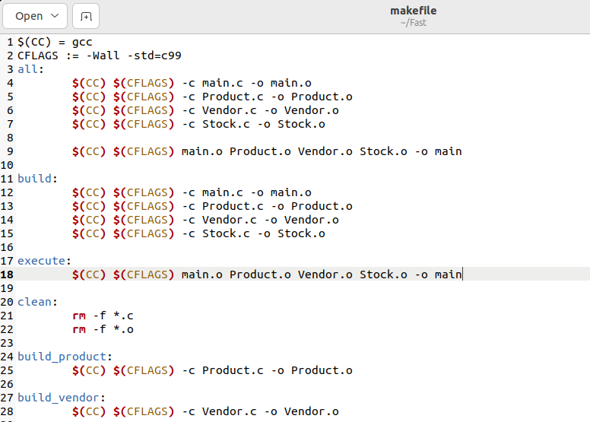

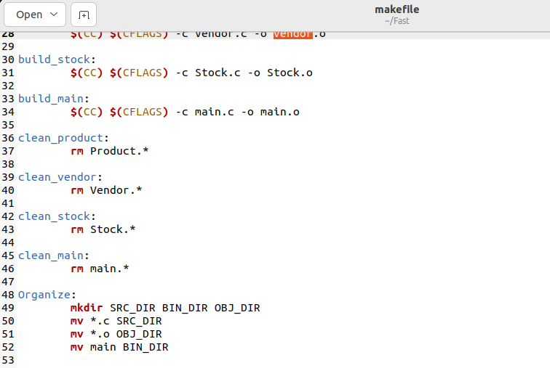

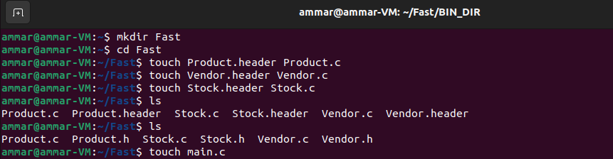





***Header Files:***

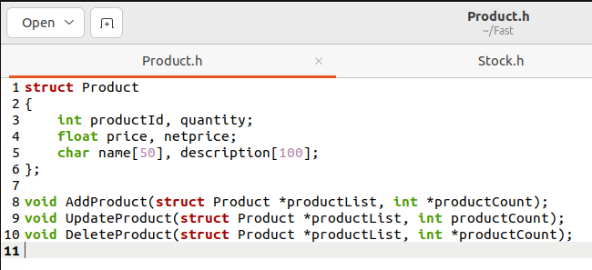

***Main:***

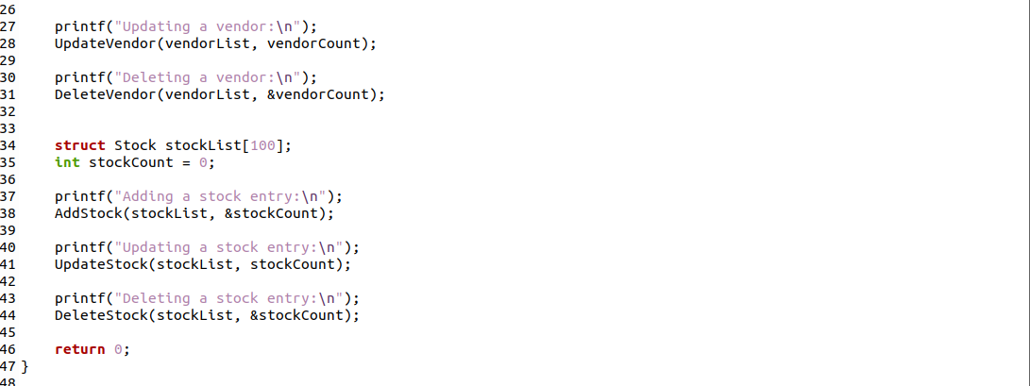

***Product:***

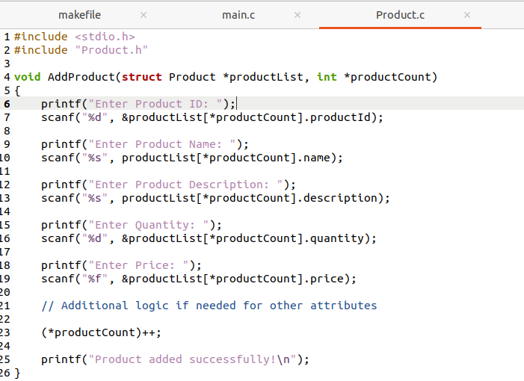

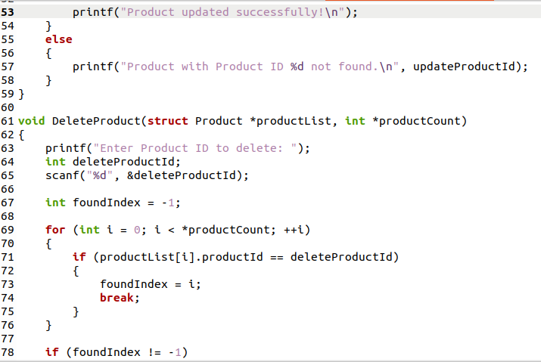

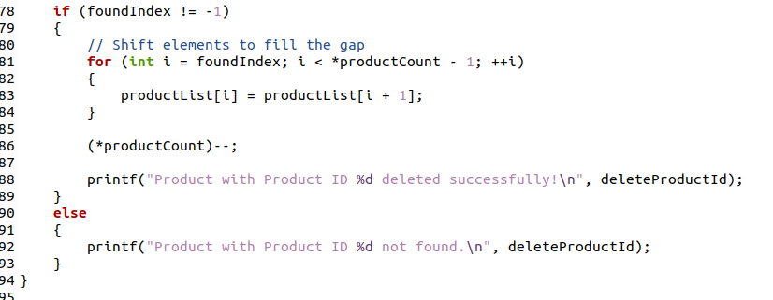

***Vendor:***

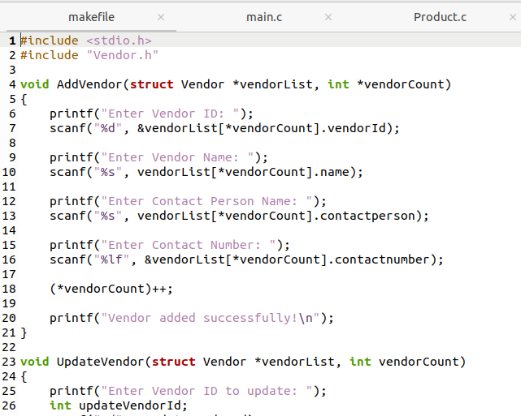

***Stock:***

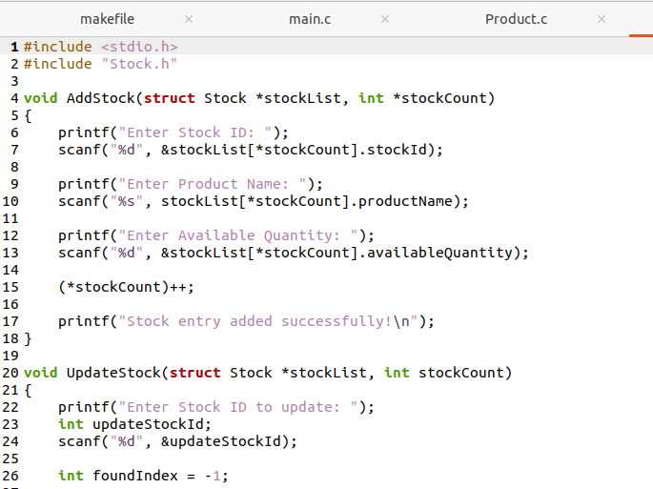

***Q2)***

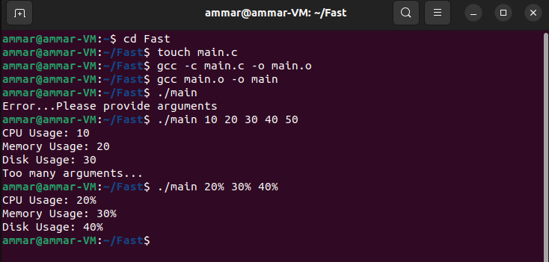

Q3)

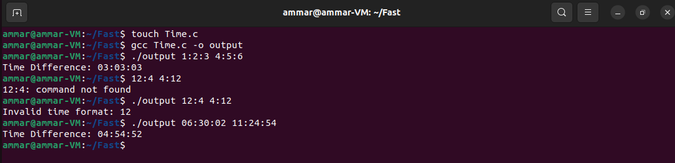

Q4)

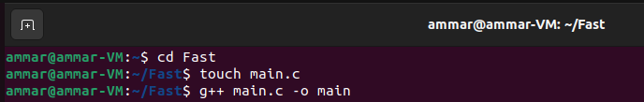

Q5)

Makefile:

Codes:

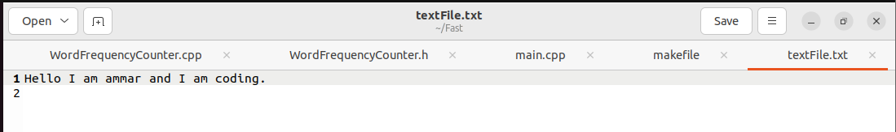

Terminal:



